**Name :- Rushikesh Anil Mashidkar**

**Email Id :-** [**rishikeshmashidkar@gmail.com**](mailto:rishikeshmashidkar@gmail.com)

**Note :- The answer is in bullets ( 🡺 )**

**Assignment Question**

**Assignment 1** :- How to upload HTML web pages on Apache2 web server in EC-2 Instance? Please justify with step by step answers.

🡺 First of All you have to Login to AWS Console with root or admin policy user. And from Console Search EC2 Service.

1. To create an EC-2 instance Click on Launch instance tab . Then type Name of your Server (ex-HTML_WebPage).
2. Select Amezon Machine Image (AMI) to Ubuntu or Anything You Want. In this program I will select ubuntu. Select Instance Type You Want And give Key Pair. If you don’t have key pair simply Create new one save on your computer.
3. Create Security Group & Allow HTTPS & HTTP Traffic From the internet with Default one . And If you want to increase storage configure it . And jump hit on Launch Instance.
4. Then Go to instance And Select the Instance which we created now and Connect via EC2 Instance Connect click on Connect. Now You have Successfully Created EC2 instance with Basic Configuration.
5. Then You have New Tab open as a Terminal[CLI] In Browser login with username by default. So you have to Switch To Root for that type sudo -s and hit Enter. Now You are root so you have to Update ang upgrade your instance by using apt update && apt upgrade command. And update it.
6. When your machine is upgraded you have to install a apache2 server. *Apache is a popular open-source, cross-platform web server that is, by the numbers, the most popular web server in existence.* For Installing apache 2 just type apt install apache2 and hit enter and then it prompt you to install yes or no. Just you have to type Y and enter.
7. Now we have Default server so you have edit the HTTP servers index file. The file is stored in /var/ww/html/ so you have go to that directory by using cd command. And then check the index file is there or not by using ls -a command.
8. For welcome landing page we edit the index.html file by nano command i.e nano index.html and then edit your welcome landing page (ex - <HTML>Hey Welcome to My New Web Server! 😊 <HTML> ). And save it.
9. For checking your landing page type ip of server you created and paste on google and see the magic we created. 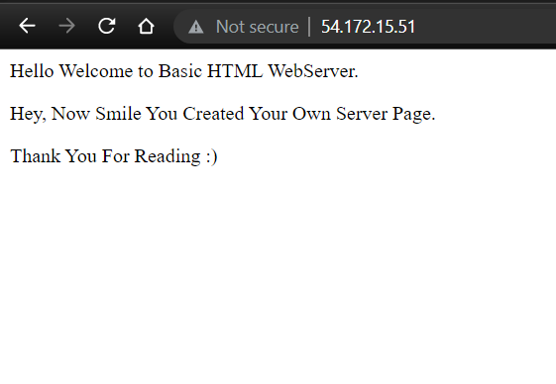

**Assignment 2** : Create readfile.sh in which you can read the information of PWD like size, permission, date time etc.

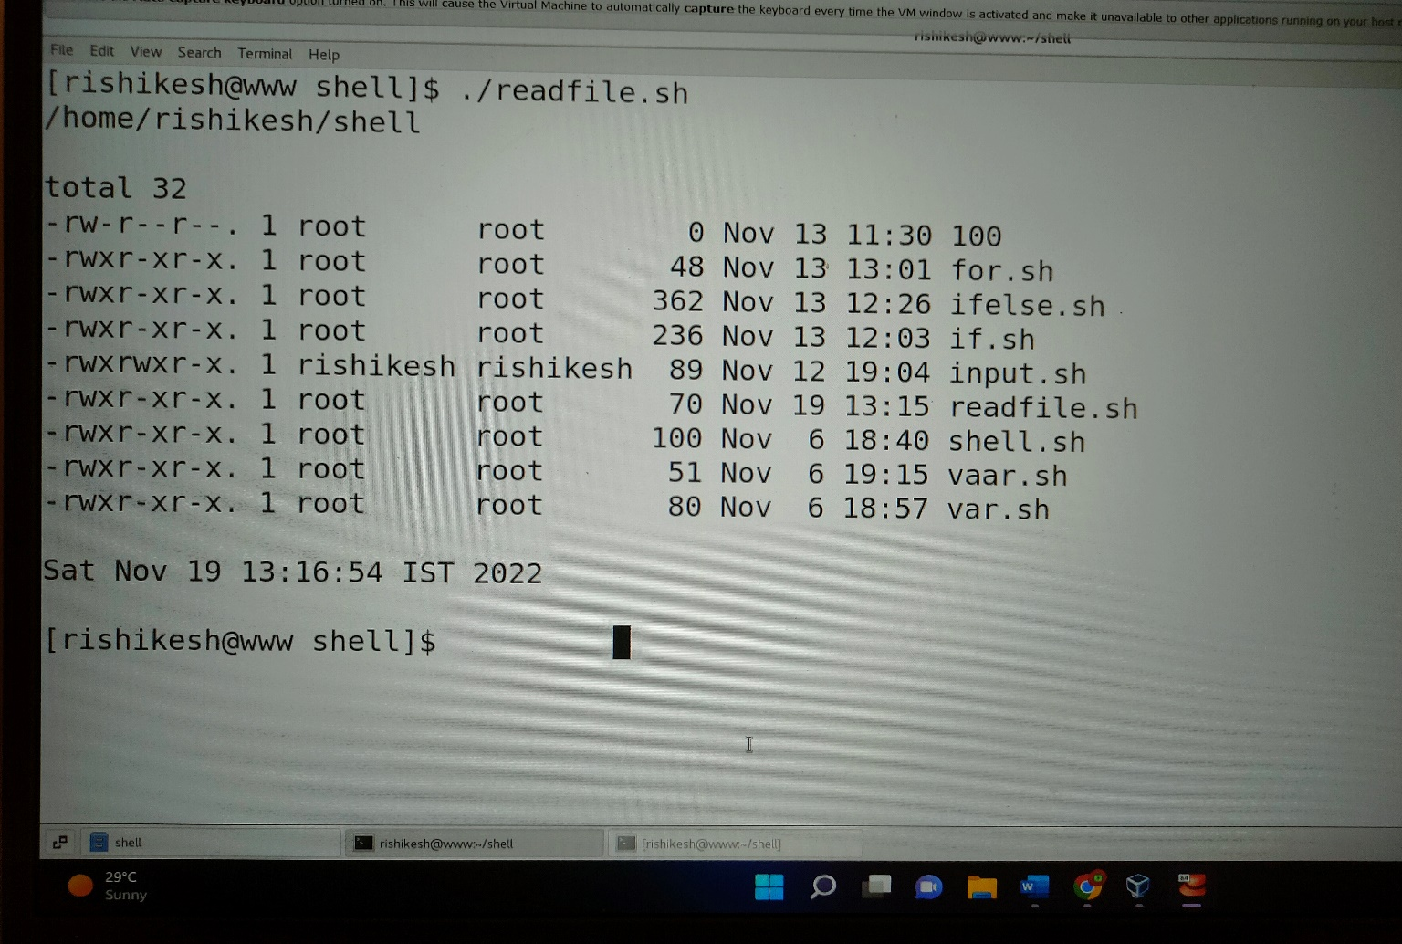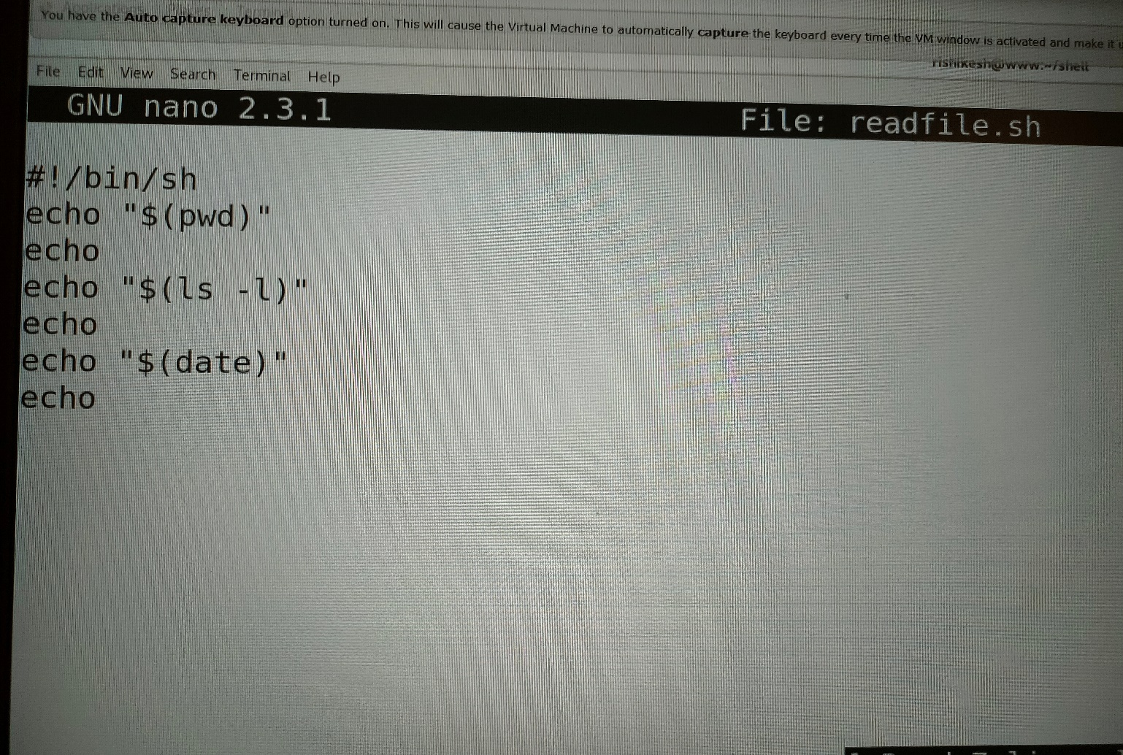

**Assignment 3** : Take an input of name from user and print Have a great day ahead {name}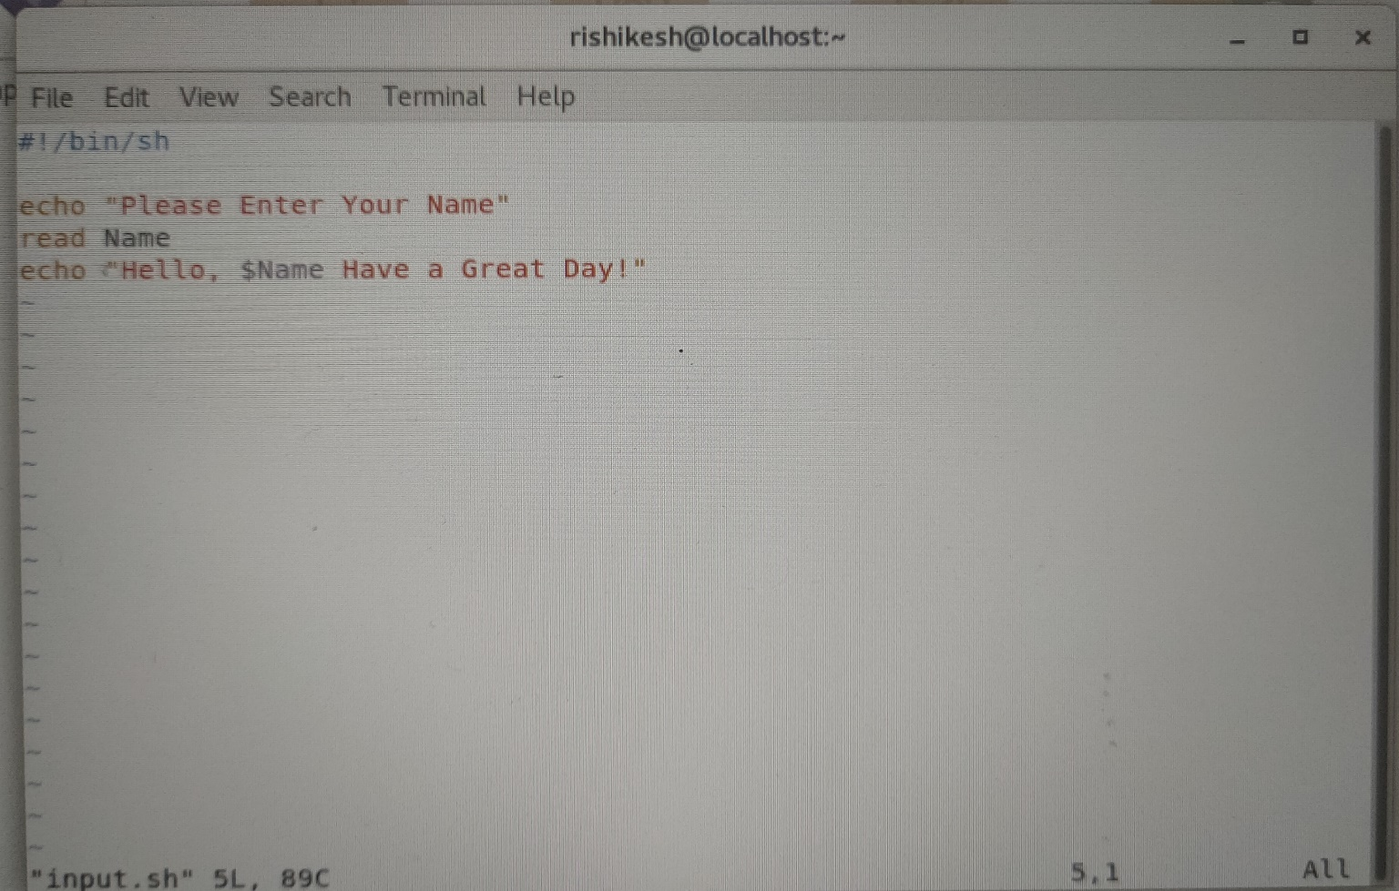

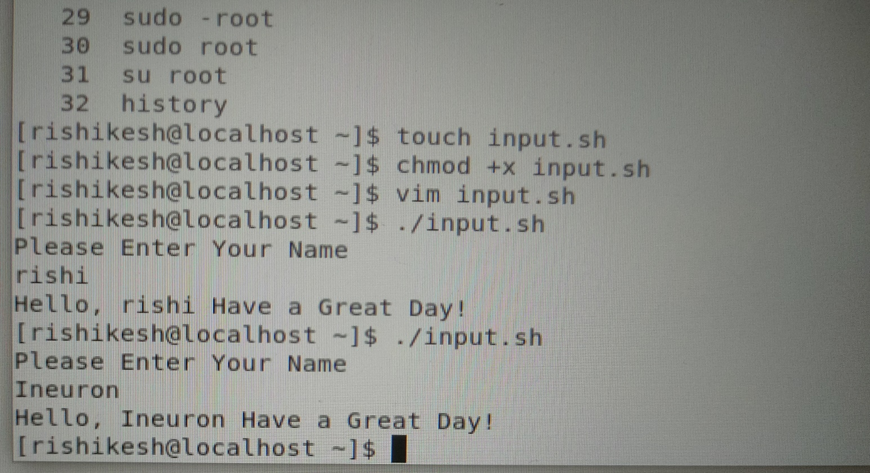

**Assignment 4** : Let’s take a scenario of fintech app program in which we want to have three separate

outputs for 3 different situations:

→The balance is less than zero

→The balance is zero

➔ The balance is above zero

For instance, in the following program, use the if, elif, else statements to display different outputs in

different scenarios:

Use “if” condition to check if the balance is less than zero. If this condition evaluates to true, display

the message using the echo command: “Balance is less than zero, Please add more funds else you

will be charged penalty”.

If the above condition does not match, then use “elif” condition to check if the balance is equal to

zero. If it evaluates to true, display the message: Balance is zero, please add funds

If none of the above condition matches, use the “else” condition to display the: Your balance is above zero.

🡺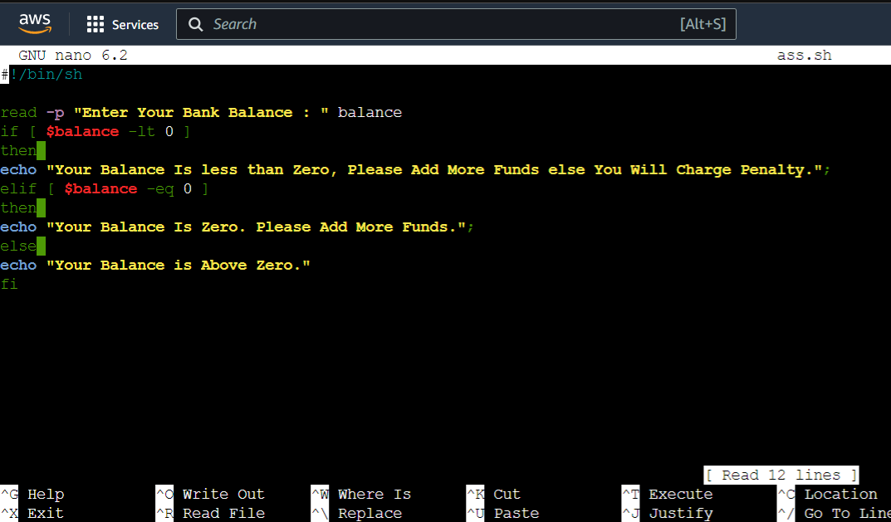

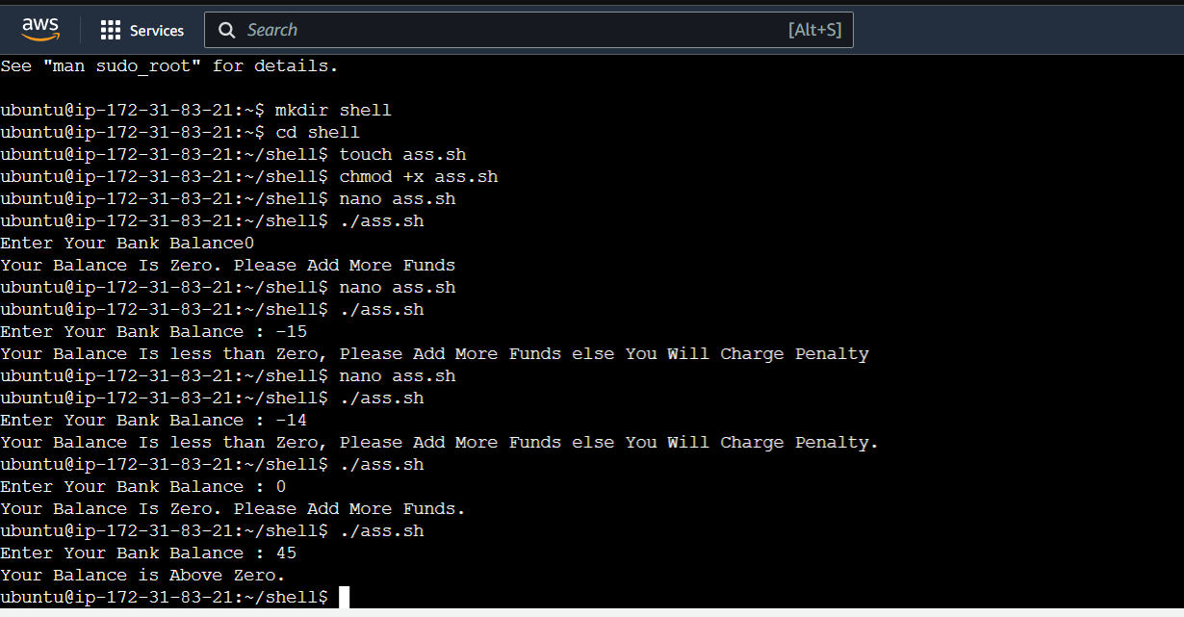

**S** : Debug and define briefly about

🡺 In the echo statement there is no double semicolon( **;;** ) at the last. We Have to write double semicolon to the echo to do further condition if the first condition evalute false. Write double semicolon at the last of each echo line and run the file it will give you the output that is disk usage massage. I provide the screenshot after debugging and also I run the the file and output is there. 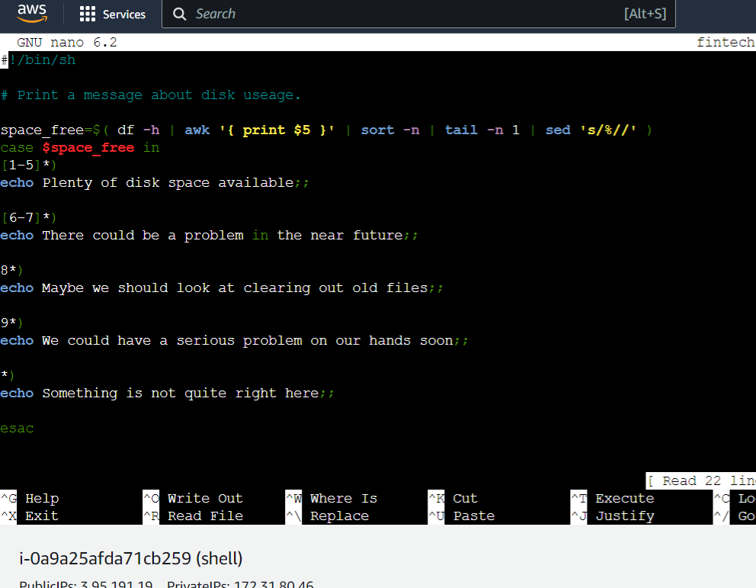

After Debugging

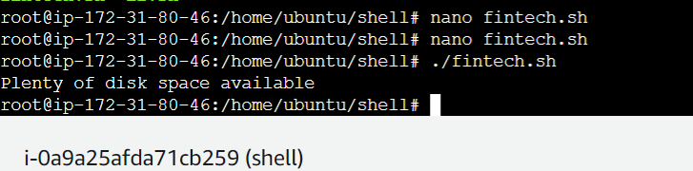

Output

The Awk is a powerful scripting language used for **text scripting**. It searches and replaces the texts and sorts, validates, and indexes the database.